Mech 12 Computational Project #1a, Fall 2015
(Due September 4, 2015)

You have a very wealthy, incredibly brilliant, and wildly eccentric aunt, Aunt Ada. Aunt Ada made her fortune as a highly innovative engineer who embraced her entrepreneurial side, spinning numerous of her inventions into profitable businesses. Aunt Ada is now enjoying quieter, golden years on her vast property in the Poconos and one of her recent delights was to learn that you enrolled in an engineering program at Lehigh University.

Though well loved, Aunt Ada has a reputation in your family for championing some pretty wild ideas. As such, you are not surprised to receive from her an invitation to her “cabin in the woods” for the weekend to hear a business proposition she has for you. Intrigued, you head on up into the mountains to visit Aunt Ada in her mountain estate.

After you settle in and get into technical discussions, Aunt Ada reveals she wants to construct what can only be described as an epic tree house. In fact, the design she has in mind is sufficiently large and the location she is considering on her property is sufficiently constrained that there are no natural trees into which the tree house can be built. Having concluded that an artificial tree needs to be constructed, she is offering you the job of designing the trunk of the tree. She points out that all of the mount points for the tree house as well as for artificial branches and leaves will be such that the trunk will effectively be loaded in a purely 1D condition. Aunt Ada goes on to say that, if your design is successful, she will pay you the full cost of a four-year education at Lehigh along with, “a little something to help you get off the ground after school.”

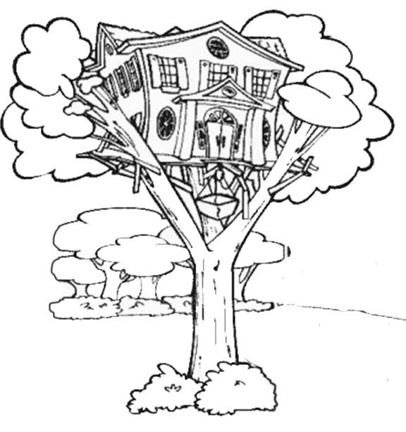
You take the job so your first phase of work is to determine relevant parameters dictating the design of the trunk. This first phase is to be done as an individual exercise; you should create a bulleted or numbered list of relevant things that must be considered in designing the trunk. In other words, what questions need to be answered and, with those answers, what do you need to do to ensure a good design. A single item in your list can be as short as a few words or as long as a paragraph. You should be as quantitative as possible and you should justify your assumptions or assertions. If necessary, include references at the bottom of your list.

“The more I study, the more
insatiable do I feel my genius
for it to be.” - Ada Lovelace

