Giulio Cristello
Capstone Project Idea
Part 1:
- A good Capstone Design project would be to have a launch and recovery system for a glider on Mars, to take picture of relevant data of the terrain around the launch base.
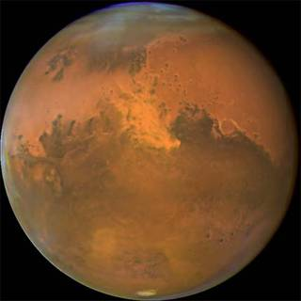
Figure 1) Mars’ terrain as seen from space [1]
The reason why this is a good idea is because whenever a rover lands, there is no good way to see the terrain around it. A rover cannot see over hills or inside a crater. If there was a way to aerially scan the surroundings, it would lower the risk of accidental damage to the rover.
- The reason I like this idea is because it is relevant. It would be beneficial for rovers that are deployed to explore Mars to have a way to know which way to go is the less risky or to know what lies around them in general.
- I think that the biggest challenge would be to test recreating the conditions found on Mars. It is going to require many calculations to account for the gravity difference and atmospheric density. “Mars’s surface gravity is 3.711 m/s², which works out to 37.6% of Earths (0.376 g),” and “It’s mean density is 3.3464 g/cm3 , which is equivalent to roughly 0.6 that of Earth,” according to Matt Williams from Universe Today [2].
- I would not present this idea in front of the class.
Part 2:
- A potential customer for this product would be any space agency that plans on sending rovers to the Martian atmosphere. For example, if for some reason Elon Musk was to stumble upon this idea, and by chance was interested, he would be the best possible customer. He is the CEO of SpaceX, and since the company is private, that would facilitate the acquirement of the project idea.
- The “pains” it would solve are related to the safety of the rovers. If a rover was to hit a hole in the ground and get stuck, that would compromise a multi-million dollar mission. For example the rover Spirit got stuck on a patch of sand, preventing it to rotate its solar panels, which lead to the complete loss of power and eventually its shutdown [3]. The benefit of scanning the terrain around a rover would be to avoid any dangerous obstacles.
Works Cited
- Dunbar, Brian. “What Is Mars?” NASA, NASA, 1 June 2015, www.nasa.gov/audience/forstudents/5-8/features/nasa-knows/what-is-mars-58.html
- Williams, Matt. “Mars Compared to Earth.” Universe Today, Universe Today, 10 Jan. 2018, www.universetoday.com/22603/mars-compared-to-earth/
- Wolchover, Natalie. “NASA Gives Up On Stuck Mars Rover Spirit.” Space.com, Space.com, 8 Mar. 2016, www.space.com/11773-nasa-mars-rover-spirit-mission-ends.html.

