Portfolio 6
Radial Engines
The Wright Brothers are credited with designing the first truly reliable aircraft engine which was an operational J-5 Whirlwind radial engine that produced 225 horsepower. The radial engine is a form of an internal combustion engine in which the cylinders radiate outward from a central crankcase similar to the spokes on a wheel. This engine is typically place in front of the nose of an airplane and has many benefits for the operation of the aircraft. The engine is compact since the cylinders are place going around one central location as opposed to be aligned linearly. The concept of placing the engine in front of the nose of the airplane is also very useful in the cooling of the engine as air is constantly moving through it as previous stationary engines had a lot of difficulty with finding a proper and efficient way to be cooled. Having the engine so far forward also always the center of gravity of the aircraft to remain forward which is essential in the case that if the aircraft would stall, the airplane would naturally fall forward (nose down) with the hopes that the pilot is able to regain control (this concept was further elaborated on in the “Ways to Reduce Wave Drag” portion of the portfolio). One negative part about the radial engine is that is a rather bulky and directly exposing it to the freestream creates a large amount of drag. All in all, this engine was quite revolutionary when it first came into use after the first World War. Below in figure one is a picture of a radial engine. It can be seen how the cylinders extend outward from a central location, allowing the engine to be more compact. (did you by any chance lookup the hp or the thrust you get from radial engines? Are there any limitations to using this engine?)

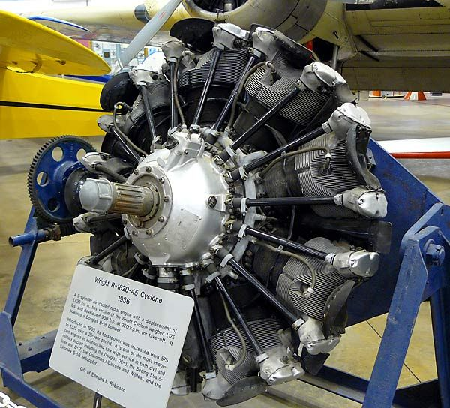
Figure 1. An example of a radial engine that was in use on aircrafts around 1936

Thrust Equation
The general equation to calculate thrust of an airplane is as follows:
Thrust = $\dot{m}V_{Exit}$ - $\dot{m}V_{Inlet}$ - (P_{Inlet} - P_{Exit}) * A_{Exit}
(Hey Mitchell, so where did this equation come from? You can at least mention the governing equations!)
This equation certainly is does not take all forces influencing thrust into the equation but it provides about the best possible approximation of how well a particular engine will be able to generate thrust. This equation is also used in order to understand how it is possible to maximize thrust by changing certain attributes of how the engine is designed in order to affect the parameters seen in the equation. The ways in which this can be done will be discussed in the following sections. It can be seen that the only parameters that positively affect thrust are $\dot{m}V_{Exit}$ as well as P_{Exit} while all other parameters are acting against thrust. The following sections will discuss how to maximize or minimize these quantities appropriately.

Ways to Increase $\dot{m}V_{Exit}$
$\dot{m}V_{Exit}$ serves as the primary way to increase thrust and since it has a positive value in the above equation, it is valuable to increase this value as much as possible when looking to maximize thrust. It can be seen that there are two values in this parameter with one being $\dot{m}$ which is the mass flow rate, or the amount of air particles going through the engine, and V_{Exit} which is the velocity of the air coming out from the exit of the engine. First, the ways in which $\dot{m}$ can be maximized will be discussed.
One way to increase $\dot{m}$ would be to simply make the engine bigger so that more air was entering the engine. However, this adds to both weight and drag which harms the efficiency and has negative effect. Therefore, the size of the engine must be large but it cannot increase in size exponentially as the ways in which it affects other forces on the airplane must also be taken into consideration. You should also note that $\dot{m}$ is also in the second term which reduces thrust. This concept is also used when referring to the purpose behind the use of propellers. The propeller spins which pushes more air backward that what would have without the propeller which in turn increases the $\dot{m}$. Making the propeller bigger as well as spinning the propeller as fast as possible would result in further increasing the $\dot{m}$, however, spinning the propeller at very high speeds also has negative effects on how the engine functions. For example, the tip of the propeller is moving faster than the rest of the propeller since it has a larger distance to cover in the same amount of time. Therefore, the tip of the propeller will reach Mach 1 before the rest of the propeller or the airplane as a whole and the tip will begin to experience shock waves which adds significant amounts of drag. The vibrations caused by the shock waves are capable of breaking propellers made from certain materials which would obviously be detrimental to the aircraft. Therefore, there are certain ways to effectively increase the $\dot{m}$, but it commonly comes at a cost. Moving onto V_{Exit}, the most common way to increase it would be through the use of nozzles which will be discussed in the next section. Good!

Nozzles
As expected, nozzles are used to speed up the velocity of a fluid as it travels through an area. The reason this occurs again relates to the $\dot{m}$ value as the mass entering the nozzle must be equivalent to the mass exiting the nozzle (Conservation of mass). This is known as the conservation of mass and can be derived using the equation $\dot{m}$ = rho * V * A where rho is the density of the fluid, V is the velocity of the fluid, and A is the area through which the fluid is flowing. As stated prior, $\dot{m}$ must remain constant, so $\dot{m}$_{Inlet} must equal $\dot{m}$_{Exit}, or (rho*V*A)_{Inlet} = (rho*V*A)_{Exit}. For the instance of air flowing through the nozzle, the rho value cannot change as the density of the fluid is not changing. However, in a basic nozzle (different types of nozzles will be discussed in the next section), the area at the exit is much smaller than that at the inlet. Therefore, in order for the $\dot{m}$value to remain constant, the velocity at the exit must be greater than that at the inlet. An example of this type of nozzle can be seen below in figure 2. It can be seen how the exit velocity is higher than that at the inlet due to the decreased area. This increase in exit velocity is used in order to generate a higher thrust with this increase in velocity. This increase in velocity is applied to the V_{Exit} variable in the thrust equation and for maximum thrust, it is essential to maximize this value.
Figure 2. A representation of how the velocity of a fluid increases in a simple nozzle

Different Types of Nozzles
There are multiple types of nozzles all designed to maximize efficiency under certain conditions. This being said, all nozzles hold the same purpose: to increase the velocity of the fluid passing through in order to maximize thrust. The two different types of nozzles discussed in this section will be a supersonic nozzle as well as a variable air nozzle, or “turkey feathers.” First is the supersonic nozzle that is utilized on aircrafts such as rockets that have a V_{Exit} value much greater that Mach 1. At Mach 1, a simple nozzle (converging section) no longer acts in the same way that it does below Mach 1 and therefore, a supersonic nozzle must be used. A supersonic nozzle diverges at the point where the fluid reaches a speed at Mach 1 (Also called as throat). This divergence, however continues to increase the speed of the fluid when it would be decreasing the speed of the fluid if it were still travelling at subsonic speeds as the same relationship between area and velocity does not hold true at supersonic speeds. (WHY IS THAT? DID YOU BY ANY CHANCE LOOK UP THE REASON FOR IT?) A supersonic nozzle then utilizes the type of nozzle discussed in the previous section as well as one that diverges. An example of this can be seen below in figure 3. It can be seen how the simple nozzle accelerates the fluid to a speed of Mach 1 before the nozzle diverges and the speed of the fluid continues to increase. This is essential in gaining the greatest amount of thrust possible since the air is flowing at supersonic speeds, but it is highly inefficient as it requires high amounts of fuel which is why this type of nozzle is only seen mainly on rockets and high efficiency military aircraft. So Mitchell, just because we use supersonic nozzles doesn’t mean they are inefficient. First, there are different definitions of “efficiency”. But we showed in class that in supersonic nozzles, there is ONLY ONE design condition in which the nozzle will be “efficient”. The reason is because there is only one condition where shock waves or expansion waves doesn’t occur in a nozzle. It occurs when the exit pressure equals the ambient pressure.
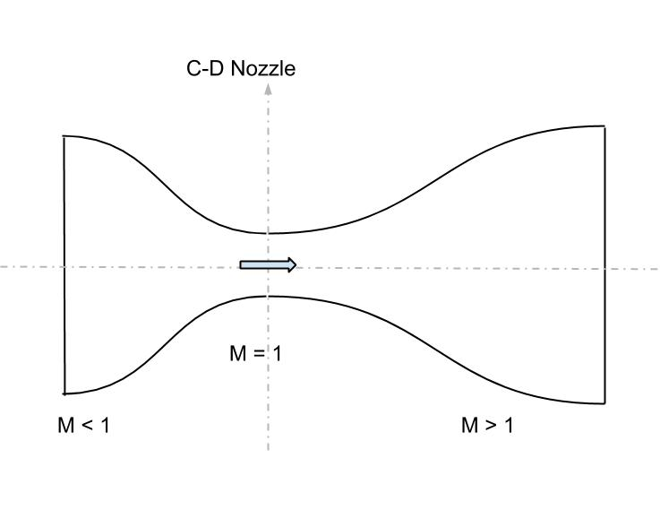
Figure 3. An example of the design of a supersonic nozzle

The next type of nozzle to be discussed is the variable air nozzle which is also referred to as turkey feathers due to the look of the design that can be seen below in figure 4. Turkey feathers can most commonly be seen on military aircraft. This nozzle is capable of operating both as a sub and supersonic nozzle, leading to the “variable” nozzle title. This is able to happen as a mechanism allows the rear of an engine to adjust from a converging to a diverging design while in flight depending on the speed of the fluid at a particular time. At takeoff, the nozzle will typically be converging (seen in left engine in figure 4) while at cruise, the nozzle will diverge in order to gain maximum trust (seen in right engine in figure 4).
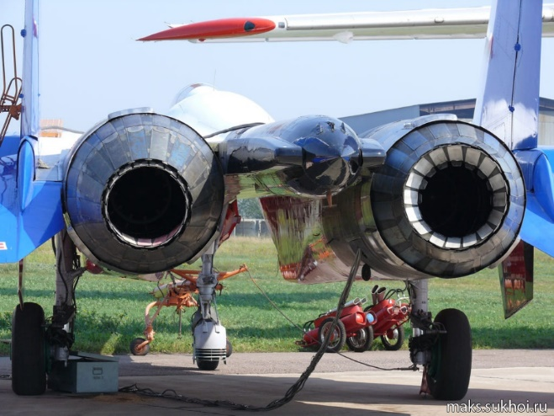
Figure 4. An example of the different settings that turkey feathers can be in

Ways to Decrease $\dot{m}V_{Inlet}$
$\dot{m}$V_{Inlet} is negative in the above equation for thrust and, therefore, it is ideal to minimize this value. $\dot{m}$in this equation is very difficult to minimize due to the fact that the value must remain constant throughout the entire equation for reasons that were discussed above. Of course, the engine could be made smaller which would reduce the mass flow rate of the air, but the negative effects that this would have to the first parameter of the equation must also be taken into account when doing such a thing. This leaves the only variable capable of being effectively reduced as the velocity of the air at the inlet. The primary way in which this can be done (for subsonic aircraft) is through the use of a diffuser. A diffuser essentially acts in the opposite way as a nozzle in which the area at the inlet is smaller than that toward the end of the diffuser while at subsonic speeds. At supersonic speeds, a diffuser is also the opposite as that of a supersonic nozzle in which the area in which the air would enter is larger than that at the exit. Both a subsonic and a supersonic can be seen below in figure 5. Neat! In some engines, the velocity can also be reduced through the use of a compressor. However, the compressor’s primary purpose is to increase the pressure of the air before it reaches that point in which it is ready to combust before leaving the engine. Compressors and their purpose in the engine will be further discussed later on in the sections regarding parts of the engine. At supersonic speeds, shock waves, which typically negatively impact the efficiency of the aircraft, can be utilized to effectively reduce the velocity of the air. This concept will be discussed in the following section.

Figure 5. A subsonic diffuser (left) and a supersonic diffuser (right)

The V_{Inlet} can also be reduced by using what is referred to as the “Double Bubble” concept. The Double Bubble is a design in which the engines are essentially hidden behind the fuselage so that the inlet of the engine is exposed to air that is traveling at a slower velocity. This design also takes advantage of the boundary layer that is attached to the upper surface of the airplane so that the engines are taking in slower are. This design concept can be seen below in figure 6. It can be seen how the engine at the back of the airplane are hidden from being directly exposed to the freestream. Neat!
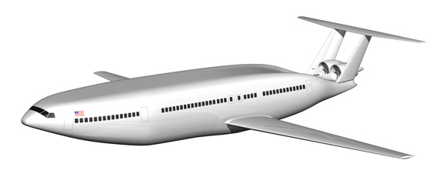
Figure 6. An example of the Double Bubble design

Shock Waves and Decreased Velocity
As discussed earlier in the portfolio, shock waves have been discussed to not be beneficial to the overall efficiency of the airplane due to the high amounts of drag that it creates. However, if the shock waves are inevitable in supersonic flight, they might as well be used in some positive way which is exactly what happens in a supersonic engine. The air in front of the shock wave is travelling at speeds above Mach 1 while the air directly behind the shock wave is reduced to speeds below Mach 1 (true with a normal shock wave which typically occurs after a series of preceding oblique shocks). This reduced velocity prior to the air reaching the engine itself assists in reducing the value of the $\dot{m}$V_{Inlet} parameter. These types of engines can have either a 1-D, 2-D, or 3-D design, all of which simply change the lip of the front of the engine in order to change the location that the shock waves hit. Each of these designs can be seen below in figure 7 . It can be seen how the oblique shock waves have tendency to reflect off the walls of the engine before reaching a point in which a normal shock occurs. It is directly after this normal shock where the air reaches its slowest velocity and that’s when the air would enter the main section of the engine. In particular, the 1-D inlet utilizes symmetrical shock waves which can be seen below in figure 7, the shock waves all meet at the same location with the 2-D inlet, and the 3-D inlet has a sort of conical shape to it. So Mitchell, one thing to note in 1D is that it forms a strong normal shock when compared to the 2-D or 3-D inlets. When there is a strong normal shock, the pressure differences before and after the shock will be huge that there will be a tremendous loss in TOTAL pressure aka very low PRESSURE RECOVERY. We want to slow the air without losing the TOTAL pressure! Which is why you don’t see a lot of 1-D inlets on airplanes. 2-D and 3-D produces a comparatively weaker normal shock which leads to higher pressure recovery.
One form of a 3-D inlet can be the one used in the SR-71 Blackbird. The SR-71 utilizes are variable length inlet spike that has the curvature seen in the 3-D inlet design. This variable length design for the spike is essential for the aircraft when it comes to reaching maximum speeds well above Mach3.

I think you could have gone a little bit deeper into the differences between the shock inlets!
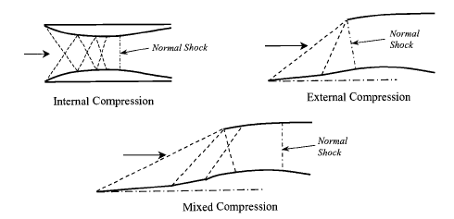
Figure 7. A 1-D (top left), 2-D (top right), and 3-D (bottom) supersonic inlet

P_{Inlet} and P_{Exit}
The final parameter influencing the thrust equation is the P_{Inlet} - P_{Exit} value. Since this value also has a preceding negative, it is important to minimize this value in order to maximize the thrust. Therefore, thrust will be greatest when P_{Exit} is greater than P_{Inlet} which is not necessarily something that is even currently possible which why do you say that? It is possible to have the exit pressure greater than the ambient pressure. You just have to increase the altitude. means that is ideal when the pressure of the exit is equal to that of the inlet which would make this part of equation equal to zero and it would no longer be hindering the thrust. However, with most values in flight, through increasing the velocity of the air at the exit, the pressure would decrease which means that through increasing one value in the thrust equation, another one is being decreased which in turn acts against the trust. There is an ideal point in which these two pressures should be for generate the most thrust. Most engines are designed to reach this point while in cruise. Slight variations from this point are what lead to shock diamonds or the fire coming from the back of crafts such as rockets. In the case of rockets, this pressure difference may generate more thrust, but it is quite unstable and the thrust begins to disperse as the fire blooms out which means that the thrust is not all acting in the correct direction which is not ideal. So Mitchell, I think you didn’t quite understand the relation between the exit and the back pressure we talked about in class? You are right in saying that the ideal case will be when the exit pressure is equal to the back/ambient pressure. But you didn’t quite connect the scenarios at which they occur. When do shock diamonds form? When do expansion waves form?

Thrust Equation Reflection
This section is intriguing because of how simple yet how complex everything is in the fact that the ways to make the thrust more efficient are so simple yet very difficult to actually make happen. For instance, the idea that in order to maximize thrust, all that needs to be done is use a bigger engine and apply a diffuser and a nozzle to the front and back of the engine respectively. Yet doing so would affect other forces such as the weight and the drag of the airplane as well as negatively influencing other parts of the thrust equation such as the pressure at the exit of the engine. The thrust equation also seems to be unique in the way that there is an actual equation to approximate the thrust when most values in regards to flight are not able to be given such an equation. This way, it is at least known to a much higher level of precision of how much thrust is being generated with different types of engines. Good! But remember that the equation of thrust we used was derived with many assumptions!

Engines
Engines are the primary source of thrust for the airplane. Engines can come in many different shapes in sizes, all tailored to be the most efficient for the purpose of each individual airplane. It is important to further study the engines as the use of them is what costs the most money in normal usage through the use of fuel. Of course, operating at a point where the cost is minimized is ideal for many situations. In cases where performance is way more important than cost, such as military aircraft, it is also important to study engines so that the performance is able to be made as good as possible as the difference between a little extra power could be the difference between life and death. The following sections will discuss several different types of engines as well as how they function.

Parts of the Engine
This section will name and describe the main parts of a common jet engine and how they function going from the intake to the exhaust nozzle. In figure 8 below is a visual of the internal parts of the engine that are being described. First will be the air intake of the engine. This is where the air is brought into the engine and the airflow is made smoother but the design of the inlet so that the rest of the engine can work with a smoother airflow. The next part of the engine that the air will encounter is the compressor. Typically, there will first be a low-pressure compressor directly followed by a high-pressure compressor due to the fact that the pressure of the air is going to increase as it moves through the primary low-pressure compressor. The compressor is made up of stages of both rotating and nonrotating components which increases both the pressure and the temperature of the air as it passes through. Following the compressors are the bypass ducts which takes the airflow from the compressor to the nozzle at the back of the engine. A shaft is also used to connect the compressor with the turbine where cooling air may travel. The shaft typically is run through the front to the back of the engine, but it is most exposed right after the compressors. Before the air is combusted, it goes through a diffuser section where the air is slowed and stabilizes so again the air will be more under control leading to increased efficiency. The air is then mixed with fuel and lit in the combustion chamber. The turbine following the combustion chamber then extracts energy from the hot air form the combustion and some of this energy is reapplied to power the compressor. Cool air from the compressor is then also used to cool the turbine, quite a relationship the two of them have. In some aircraft, an afterburner will be next where fuel is again injected into the engine in order to raise the thrust by raising the temperature and velocity of the air, but extra fuel costs extra money so this is not always used. Next is the nozzle that holds a purpose that has already been discussed above. Each engine will of course be different but these are the main components.
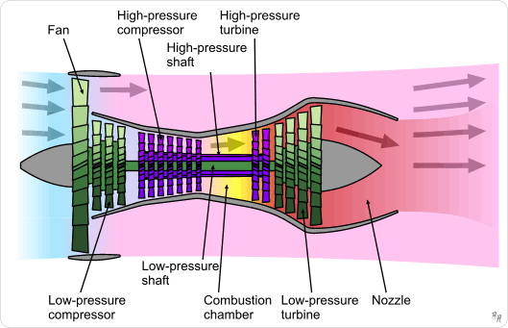
Figure 8. An example of the internal systems in an engine

Engine Noise
Engine noise does not necessarily have an impact on the efficiency of the aircraft as a whole but it does have certain applications with commercial flight as with military aircraft, having a loud engine is very low on the list of priorities if not a stealth aircraft. However, with a commercial aircraft that is commonly flying over the heads of many civilians, noise pollution coming from the engines is a much more prevalent issue. Therefore, reducing engine noise can be very important to the overall pleasantries that come with air travel. You are right about that! The noise can be reduced by using things such as scalloped exhaust where multiple exhaust nozzles are used to mix the air coming from the exit of the air which correlates to less noise being generated. Chevrons can also be used on the back of the nacelle so that the hot air coming from the engine meets the colder outside air at different points which creates less noise. An example of cheverons at the back of the nacelle can be seen in figure 9. Engine noise can also be reduced by placing the engines above the fuselage of the aircraft so that the fuselage is able to block the noise before it goes back toward the ground.
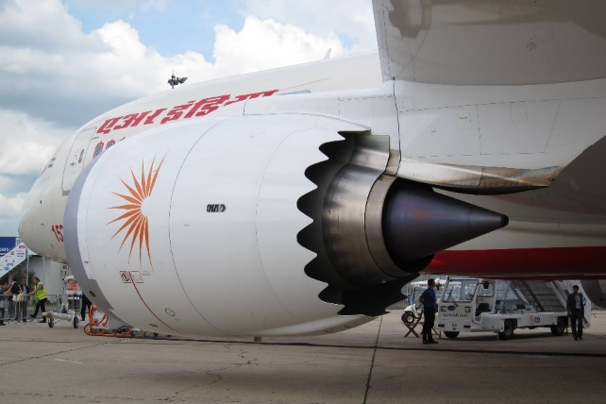
Figure 9. Chevrons on the back of an engine used to reduce engine noise
Types of Engines
There are many different types of engines, all designed to fit the airplane’s purpose. Three particular types of engines that will be discussed in this section are the turbojet, turbofan, and turboprop engine. The first type of engine to be discussed is the turbojet engine. This type of engine is used with high speed aircraft due to the fact that the efficiency is drastically lower at slower speeds as it relies on increasing thrust by increasing the velocity at the exit. An example of a turbojet engine can be seen below in figure 10. Did you by any chance look up the nominal thrust from a turbojet engine? The next kind of engine is the turbofan engine that is used in more medium speed aircraft. The turbofan differs from the turbojet in the way in which it utilizes the use of a fan at the inlet and also in the way in which some of the air bypasses the turbine all together. This means that some of the air is not even combusting, just simply moving through the engine after it is pulled in by the fan. This bypass air accounts for nearly 90 percent of the total thrust alone without the combustion or compression. The turbofan increases thrust through pulling extra air with the fan, increasing the mass flow rate of the air. A turbofan engine can be seen above in figure 8 as it was used as an example when describing the parts of the engine. Did you by any chance look up the nominal thrust from a turbofan engine? The final type of engine to be discussed is the turboprop engine. The turboprop engine is used with slower aircraft when compared to both the turbojet and turbofan engine. This type of engine is also much more simplistic than the other in the way that is only consists of an intake propeller, a compressor, combustor, turbine, and nozzle. This design can be seen below in figure 10. Like the turbofan engine, the turboprop increases trust though increasing the value of the $\dot{m}$ as the propeller brings in more air. A turboprop engine can utilize either one or two propellers. The advantage of using two propellers being that with just one propeller, the air is spun and does not allow the rest of the engine see clean air. Through the addition of a second propeller, this swirl is drastically reduce and the engine can see more clean air. However, most of the engine’s power is designated toward powering the propeller alone and the addition of a second propeller only further adds to the amount of power that is needed which would take extra fuel and in turn, cost extra money. That’s right but did you by any chance look up the nominal thrust from a turbofan engine?

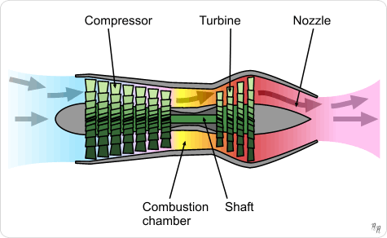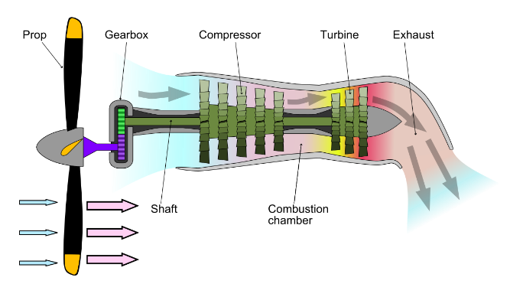
Figure 10. A turbojet engine (left) and a turboprop engine (right)

Engines Reflection
Engines are an interesting topic to look into due to the natural simplicity of an engine as it is something that people use every single day. However, the underlying functions of these engines is exceptionally complex. It was really interesting to have the speaker from NASA come in as she was able to show how engines are not only being research to be made bigger and faster, but how they can be quitter which would be more appealing to the public because no one wants to hear a ridiculously loud engine flying overhead or as they sit next to the wing on a flight. I found this interesting in the idea that even some of the things that may go without even being thought about when considering flight are being deeply studied and researched in an attempt to perfect them. She also brought in a great perspective as much of the research was her own and she was able to fully explain what her research was about with very specific examples. Engines and the fuel they use each flight also cost a significant amount of money. Therefore, moving forward, it is important to understand and perfect their functionality in order to fly from place to place in the cheapest way possible for commercial flight. For military flight, it is important to understand engines so that their performance can be maximized because every extra inch could be the difference between life and death.

Global Reflection
I enjoyed writing this portfolio. Maybe partly because I knew I have finally finished this masterpiece (might really be stretching the meaning of that term) well, in a way it is!, and partly because I found the topics discussed to be very interesting. It was also very interesting to play around with some different parameters and think about how each of them can be maximized or minimized. I feel as if I wrote this portfolio slightly slower than previous ones, but that could be due to the fact that I did a little more research into some of the topics that I found more interesting. I enjoyed taking a day back and listening to the visitor from NASA as it was a refreshing yet very educational break from our typical day to day activities. The glider activity was also very enjoyable as we were able to see how even a tiny, cheap glider acts in a very similar way to a full-size airplane. I also see it as being important to see something happen right in front of us in order to fully understand what is going on and the glider activity allowed us to do just that! Overall, this was a good way to end the main portions of the class for the semester. Now onto diving into the passion project! Neat!

Final Reflection
I can easily say that I will take more away from this class than I have from any other course that I have been in throughout my academic career up to this point. This also came with a sufficient amount of individual research and a goal to fully understand every topic that was discussed in every single class. However strenuous that had become, I was able to learn a lot and very much enjoyed and found the experience exceptionally rewarding despite the complaining that might have occurred in the moment. I have only ever flown in an airplane once before in my life yet the aerospace field still manages to hold a tight grasp on my heart and on my mind and I could not imagine pursuing anything different. That’s what I call passion! Since I was much younger, I would always look up to the sky and marvel at the machines soaring through the air. This course deepened my fascination and ensured the fact that I am pursuing the correct field for myself. I appreciated how we were able to discuss a topic in the classroom and then go out somewhere such as the Air Force museum, the Wright Brother’s museum, Huffman Prairie, the flight simulator, or the wind tunnel and see the things we talked about in class in real life. There certainly is nothing like defying all that should be possible and take to the skies. Thank you, Sid, for all that you do to help young engineers understand these concepts every year. I know it is not easy by any stretch of the imagination. I will carry what I have learned in this class with me for a lifetime. Godspeed, and may the laws of the universe continue to only be a suggestion.

“Don’t be afraid to think crazy because that’s what works.”

-Professor Sid

Great job Mitchell! You have put consistent effort into all aspects of this class and I really appreciate it. Passion and willingness to work hard are the important things which makes you successful in this field. So keep up the good work and I wish you all the best in all your endeavors. Hopefully I will see you in future aerospace classes.

