MEE 225
Fall 2017
Introduction to Flight
Syllabus
I. Course Information
Class Days/Time: TR 9.30 AM – 10.45 AM
Classroom: KL 304 (Only the first class). Classes will be held in Art Street Creative Space for the rest of the semester.
Pre-Requisites: PHY 206
Instructor: Sidaard Gunasekaran (You can call me Sid)
Office Location: KL 363 C
Email address: gunasekarans1@udayton.edu / gsidaard@gmail.com
Work Phone: 937-229-5345
Cell Phone: 937-229-3527
Office hours: I keep an open door policy but text/email/call to make sure I am in.

II. Course Outline
This course is an introductory course designed to provide you with a basic understanding of the multitude of disciplines that comprise the aeronautical engineering profession. A background and brief history of flight are covered. Foundational knowledge of aerodynamics, propulsion, aero-structures, aircraft performance and aerospace vehicle design.

The concept inventory can be found in the appendix of the syllabus.

Computer Usage:
Computers may be required to perform some basic aerodynamic and structural analysis and simulation

Laboratory Projects:
- The wind tunnel may be used for demonstrations of Bernoulli, lift and drag coefficient variations, and pressure variations
- The flight simulator may be used to provide real-life flight performance testing of Takeoff, Landing, Turn, Stall, Glide, Endurance and Range performance.
- The INSTRON may be used to demonstrate basic material properties.

III. Special note from the instructor:
Welcome to the Introduction to Flight class! In this class, I hope you will not only learn about flight and airplanes but also learn about the history and the legacy of the aerospace engineering profession. Thousands of scientists and engineers devoted their time and effort to make the field what it is now. Some of them even made their ultimate sacrifice. Their efforts redefined what was impossible and what a human can do. Therefore, as a future generation of engineers, we owe it to them and the profession to put our best efforts to learn, understand, appreciate and realize the beauty of this field and make a decision based on what we learn to pursue this as a career of our lifetime or not. Please don’t take this class for requirement purposes or for grades. I hope you approach this class and the material with genuine interest because this is a subject like no other.
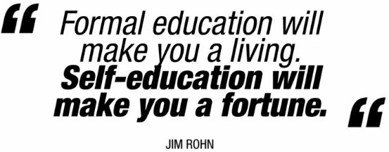
IV. Learning Resources:
The topic of Introduction of Flight is so vast that it does not make sense to follow just one book. Hence, there is no “required” textbook for the class. I WILL NOT ASK YOU TO SOLVE MINDLESS BACK OF THE CHAPTER HOMEWORK PROBLEMS. You will use several resources such as books, the internet, magazine articles, etc to learn about the subject.
1. Books:
Recommended Book: "Introduction to Flight", 7th Ed., Anderson, John, McGraw Hill
(For anyone who is starting in this field, Anderson’s book will be a good start. However, Anderson, nice person that he is, oversimplifies some topics so that any nonprofessional could understand. While that is extremely helpful, in some areas, we will dwell deeper than what Anderson provided and explore topics, which are not discussed in his book. So please do not just stick to this book alone. You NEED to refer other resources as well.)
2. Online Resources:
(More often, you will use google to research and do an independent study on some topics in the class. It is very important that you cite the website/paper, etc in your work. There are many online resources (mentioned below) which could help you learn more about the subject.)
MIT Open Course: https://ocw.mit.edu/courses/aeronautics-and-astronautics/16-00-introduction-to-aerospace-engineering-and-design-spring-2003/index.htm
NPTEL Open Courses:
- Introduction to Experiments in Flight - https://onlinecourses.nptel.ac.in/noc17_ae02/preview
- Introduction to Airplane Performance - https://onlinecourses.nptel.ac.in/noc15_ae02/preview
History of Aerospace Engineering - http://theageofaerospace.com
Edx Courses: Introduction to Aerospace Engineering: Astronautics and Human Space Flight (The online course starts on September 26th)
https://www.edx.org/course/introduction-aerospace-engineering-mitx-16-00x-1?utm_source=OCW&utm_medium=CHP&utm_campaign=OCW
3. Android apps
Below are QR codes for some fun and useful mobile apps.
iOS version available at http://www.algorizk.com/
4. Software
Please download and install XFOIL or XFLR5 and MATLAB in your laptop. You will be using these programs in the class throughout the semester.
V. Learning Outcomes
Everything we do in this class is to achieve the following five learning outcomes. The learning outcomes are:
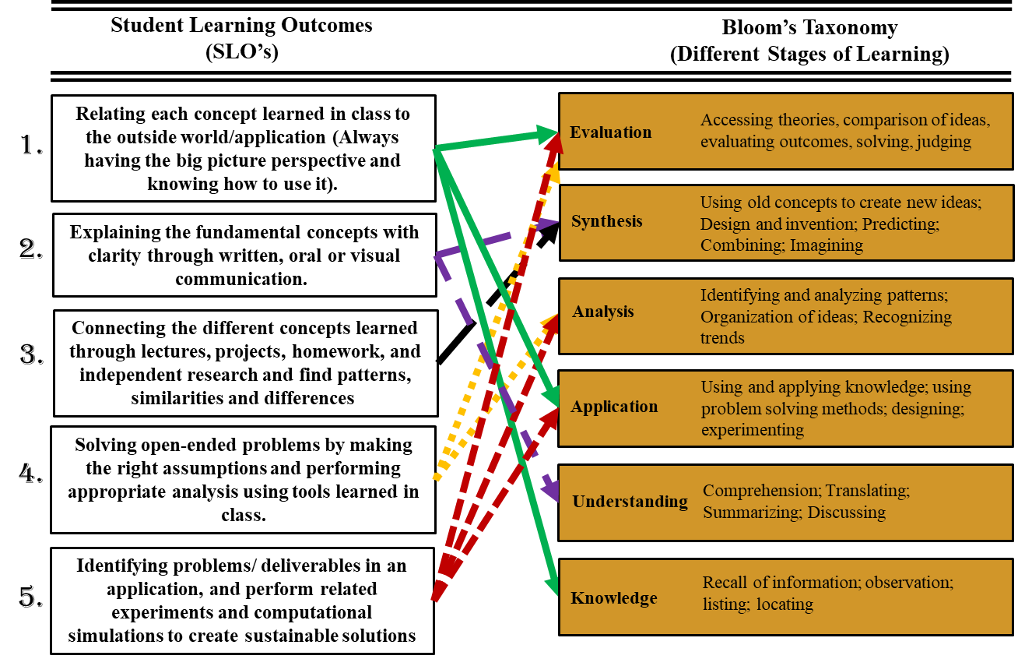
As you can see, all the five learning outcomes satisfies Bloom’s different stages of learning. Most classes only attend to the bottom two (knowledge and understanding). But in this class, we are going to do several things to attain much higher levels of learning.
Focus on
Skillset + Mindset
In this class, we will be using different pedagogies (teaching process) for you acquire different skillsets. But we won’t stop just with the skillset. We are going to focus on the **mindset** as well. Without training your mindset, acquiring just the skillset will be of no use. We are going to train you to think right, think smart, have the right attitude, the right approach and the right mindset where you can find opportunities to become successful. Mindset will provide you with the correct direction where you can apply your skillset.
In order to develop your mindset, we will focus on the following 4 C’s throughout this course.
Creativity Curiosity Connections Creating Value

V. ASSESSMENT TOOLS
Our goal in this class to achieve the objectives listed in the section above. Just from the outset, you can tell that exams don’t provide a way to assess those objectives and mindset. Therefore, your progress in this class will be assessed through your “Portfolio”, homework assignments and Projects.
1. Homework Assignments and Quizzes: (Individual assessment)
In the homework assignments, I will ask you to do some of the following:
- Give a narrative explanation for open ended questions.
- Solve open-ended problems.
- Do independent studies on the topic of your interest.
- Write summary and reflection on magazine articles
- Get quantitative feedback on pedagogies.

2. Innovation Challenge: (You will work with a teams of 4 and will be assessed as a team)

This is a fun project designed for you to develop your mindset as well as find opportunities in the field of aerospace engineering. Information about this challenge will be revealed on the first day of the class.

3. Passion Projects: (You will work with teams which shares your interest and will be assessed as a team)

This project will commence at the end of September. More information on the project will be given in a separate handout around mid-September.

4. Portfolio: (You will work with a partner to write a portfolio for this class and will be assessed as a team)
Your team’s portfolio in this class will be a compilation of class discussions, homework assignments, and several other elements. Metaphorically, these different aspects of the class are like pieces of puzzles which you have to put together the way you understand the subject and not the way I teach it.
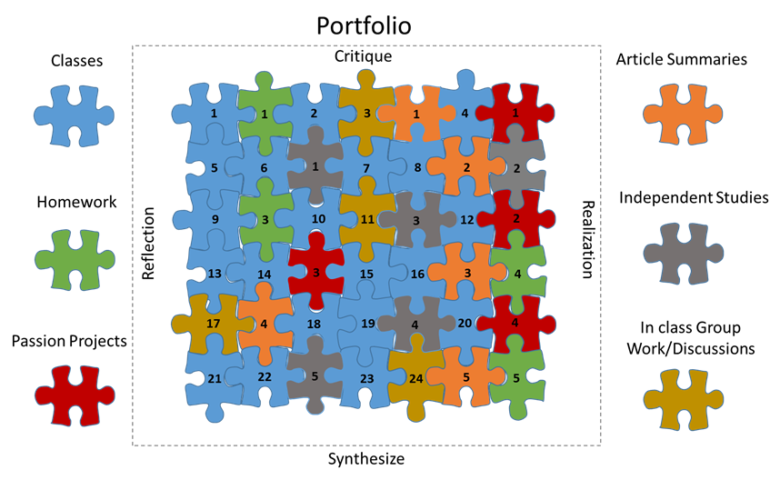
As such, the completed puzzle in your portfolio will be unique to each team in the class and will reflect your true understanding and knowledge. In the portfolio, you will discuss the technical content you learned in different classes. The homework assignments and projects are conceived in way that it fits in between the concepts taught between two classes. For example, as you see in the figure below, the concepts covered in class 1 and class 2 are interlinked by the homework assignment 1. And it is necessary for the you to solve Homework 1 in order to understand the concepts discussed in the second class. Email me your favorite airplane to get 5 extra-credit points before our second class as a proof of reading this syllabus.
Format and Organization of the Portfolio:

There is NO SET FORMAT or ORGANIZATION for the portfolio. You can format and organize it any way you want. There is only one condition you need to be aware of -

**YOU SHOULD NOT CATEGORIZE YOUR PORTFOLIO CONTENT IN TERMS OF CLASSES AND HOMEWORK ASSIGNMENTS**

There should be no use of the word classes or “homework” or “classes” in your portfolio. Your portfolio needs to flow well which means you have to connect the things you learn in class, homework assignments, article summaries, group discussions, etc.

Portfolio Assessment:

Each portfolio will be graded on the following category:
- The level of technical detail in the explanations.
- Quantity of technical content covered.
- Integration of ideas and concepts from multiple aspects of the class.
- Independent studies on topics related to class discussion.
- Inclusion of figures, graphs, and other visual aids to explain a certain concept.
- Local and Global Reflection on concepts learned.
- Overall impression of professionalism and effort.

The total points for each portfolio draft will depend on the level of difficulty. The grading scale for undergraduate students is shown below.
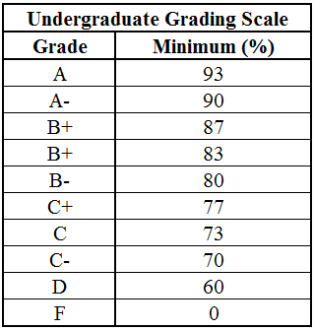
As an educator, I believe a lot in portfolio because it forces you to learn for the sake of learning and not for the sake of exams. And no matter how diverse the class is in terms of knowledge, learning capabilities, retention, etc, portfolio will provide the same increment to everyone in the class. This semester, we have students all the way from freshman to senior. Giving exams just wouldn’t be fair.
VI. Classroom Protocol
All electronic devices including cell phones must be turned off and are not to be visible at any time during class unless specifically directed by the instructor. Notebook computers may be used in class for taking notes and specified in-class activities, not for instant messaging, email or other distractions.
In addition, as a student in this class, you are expected to:
- Take ownership and responsibility for the conduct of the class.
- Always treat class members with respect.
- Be considerate and limit materials or actions that others might find distracting, such as conversations, work from other classes, newspapers, video games, etc.
- Be prepared to contribute to group and class discussions in a courteous, substantive, and thoughtful manner.
VII. University Policies:
Classroom Protocol
Notebook computers may be used in class for taking notes and specified in-class activities. All e-mail messages will be sent to you via your University e-mail account, so you should be in the habit of checking that account every day, or you should ensure that Google forwards messages to another account of your choice. To verify your e-mail address, visit http://address.udayton.edu.
In addition, as a student in this class, you are expected to:
- Take ownership and responsibility for the conduct of the class.
- Always treat class members with respect.
- Be considerate and limit materials or actions that others might find distracting, such as conversations, work from other classes, newspapers, video games, etc.
- Be prepared to contribute to group and class discussions in a courteous, substantive, and thoughtful manner.
- Bring necessary materials to every class.
Academic Honesty
I encourage you to talk with each other about the readings and ideas brought up in class. I also assign a great deal of group work. However, for all assignments to be graded as individual work you are expected to do your own written work. In the case of group work, all members of a group will be held responsible for the content of work turned in to satisfy group assignments. I will use various tools such as Turnitin to check for plagiarism. Please note that plagiarism will NOT be tolerated in this class. Minimally this can result in the loss of credit for an assignment, however, more serious penalties may also be employed depending on the severity of the case. Here is some advice to help you avoid plagiarizing:
It is best to express the ideas you use in your own words. In the case of both individual and group work, words or ideas that come from someplace or someone else must be cited. “A good rule of thumb is this: Whenever you consciously borrow any important element from someone else, any sentence, any colorful phrase or original term, any plan or idea – say so, either in a footnote, bibliography, or parenthesis” (from “Academic Honesty in the Writing of Essays and Other Papers,” Carleton College, 1990).
For specific university policies concerning academic honesty, see the University’s Academic Honor Code.
Dropping the Course
You are responsible for understanding the university’s policies and procedures regarding withdrawing from courses, including the ‘withdraw without record’ and ‘withdraw with record’ dates.
VIII. University Services (free for all students)
Support for Your Learning in This Course
The Ryan C. Harris Learning Teaching Center’s Office of Learning Resources (OLR) is a learning resource for students, parents, faculty, and staff at the University of Dayton. OLR offers a wide variety of information and services to help everyone become a successful learner. Peruse the website, attend one of our offerings, or contact our office and meet with a staff member – however, you look at it, OLR is your partner in learning! Please contact OLR at 937-229-2066 (TTY 937-229-2059 for deaf/hard of hearing individuals) or visit the office on the ground floor of Roesch Library (LTC 023) if you would like to talk about how you could become a more effective learner. You can also check out the website: go.udayton.edu/learning.
Students with Disabilities
Your learning in this course is important to me. I invite you to come talk with me about ways to ensure your full participation in the course. If you anticipate or experience physical or academic barriers based on disability, please let me know immediately so that we can discuss options. You are also welcome to contact the LTC’s Office of Learning Resources (OLR) to discuss reasonable accommodations. Please contact OLR at 937-229-2066 (TTY 937-229-2059 for deaf/hard of hearing), by email at disabilityservices@udayton.edu, or stop by OLR in the LTC (room 023 Roesch Library). If you have an accommodation letter provided by OLR, please contact me to discuss. If you need assistance accessing print material including textbooks and electronic material such as PDF documents, please review the OLR website information about alternative formats under Disability Resources. (go.udayton.edu/disability Alternative Formats)
The Knowledge Hub
The Write Place and Roesch Library’s reference services have united in a newly renovated space called the Knowledge Hub on the first floor of Roesch Library. In the Knowledge Hub, all UD students can receive free research and writing assistance on any assignment, at any stage of the writing process. No appointments are necessary (though you’re welcome to make one; call 937-229-4270). For more information, visit the first floor of Roesch Library. For details about services provided by either the Write Place or Roesch Library, see the Get Help page: https://www.udayton.edu/libraries/help.php. I strongly encourage you to take advantage of the Write Place. This will factor into the grading of your portfolio.

CONCEPT INVENTORY
FOR
MEE 225 INTRODUCTION TO FLIGHT

Please note that the order of the topics presented below is not set in stone, and is **MORE** likely to change depending on the flow and preferences of the class.

Background
Basic Nomenclature and Origins
The Anatomy of the Airplane
The 4 Basic Forces on an Aircraft in Flight
Wing Loading and Thrust to Weight Ratios

A Brief History of Flight
The Dinosaurs, Fish, Birds and Insects
Man Ponders Flight – The Evolution of Technologies Leading to Human Flight
Man Begins the Pursuit of Flight Within the Framework of the Scientific Process
Man Conquers Controlled, Sustained Flight
The Cantilevered Mono-wing
The Turbojet
The Sound “Barrier”
Rocket Planes and Hypersonic Flight

The Standard Atmosphere
Definition of the Standard Atmosphere
Characteristics of the Standard Atmosphere
Mathematical Description of the Standard Atmosphere
Definition of Altitude
Pressure, Temperature and Density Altitudes

Applied Aerodynamics
Bernoulli’s Equation and the Role of Dynamic Pressure
The Definition of the Pressure, Lift, Drag, & Moment Coefficients
2 Dimensional Wing Profile Characteristics and How They Vary
C_{L} vs α, C_{L} vs C_{D}, C_{M} vs α (Airfoil Characteristics Discussion)
3 Dimensional Wing and the Definition of the Components of Total Drag
Planform Effects – Taper, Aspect Ratio, Sweep, Oswald Efficiency
Lift Induced Drag
Base Drag
Pressure vs Viscous Dominated Flow
Compressible Flow and the Mach Cone
High Lift Devices
Whole Aircraft Lift, Drag,
Lift to Drag Ratio

Applied Structures
Elements of Aircraft Structures
Importance of Strength, Stiffness and Buckling
Materials
Importance of Fatigue
Loads
The Cutting Edge of Structures Technology

Propulsion
Thrust and Efficiency
The Propeller
The Reciprocating Engine
The Turbofan, Turbojet and Turboprop Engines
Afterburning
Alternative Powerplants
Power and Specific Fuel Consumption Variation with Altitude and Velocity
The Cutting Edge of Propulsion Technology

Aircraft Performance In Steady Flight
The Equations of Motion for Steady, Level Flight
Thrust/Power Required
Thrust/Power Available and Maximum Velocity
Drag Divergence Effects on Maximum Velocity
Minimum Velocity-Stall
Service and Absolute Ceilings, Rate of Climb, and Time to Climb
Gliding Flight
Range and Endurance for Propeller Driven and Jet Propelled Aircraft

Aircraft Performance In Accelerated Flight
Takeoff and Landing Performance
The Level Turn with Minimum Turn Radius and Maximum Turn Rate
The V-n Diagram

