Making Connections to KEEN framework:
Given the rigor of engineering content and how engineering has been historically taught over the years, students have the tendency to dive into the forest of equations, theory, and data when solving an engineering problem without thinking about the ramifications of their decisions. In order for students to maximize the value created in their recommendation for the Breakin’ Wind project, it was critical that they learn how to “Integrate information from many sources to gain insight”, that is the 2nd “C” of the KEEN frame – “Making Connections”. Specifically, students should be able to integrate information from stakeholders, weighing the input of many who would be affected by a specific engineering decision based on analysis of static loads. This became our learning outcome for this entrepreneurial minded learning module.

Then, we designed an active-learning role-playing activity, involving “Stakeholder Theatre” where students assimilated various stakeholders and were asked to conduct a stakeholder analysis, create a poster, and do a gallery walk, and pitch the key linkages, takeaways, and ah-ha moments. The activity was designed in a way to make the learning stick by building in tensions into the analysis while the role playing made it fun and engaging. They were given a brief explanation on how to conduct a stakeholder analysis prior to engaging in the role-playing activity. The following frameworks were provided below:

Stake-holder | Interest:  How affected by problem or project? | Perspective:  Key ideas about problem or project | Assets: Resources, skills, & abilities | Constraints

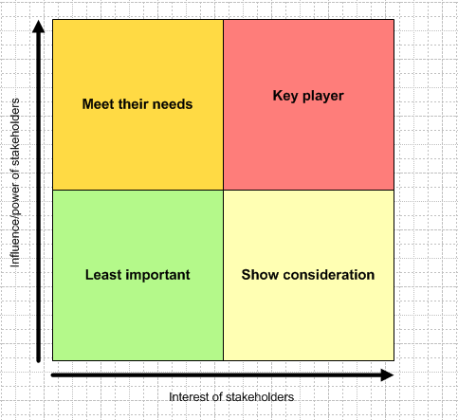
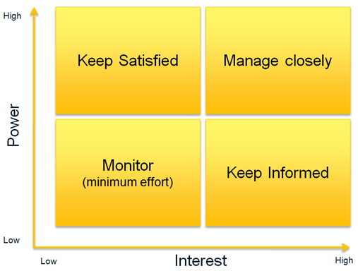

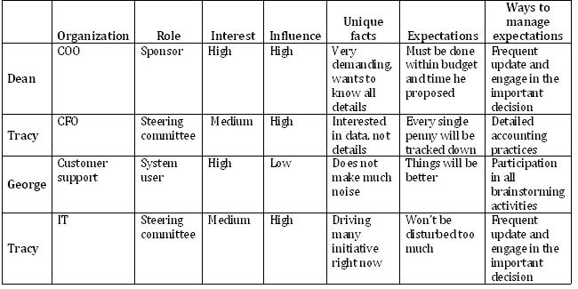

Stakeholder | Influence | Benefits | Barriers
Female Water Users | Very High: co-designers and users | High if IS is implemented | Moderate: need for training, social pressure
Water Manager | High: co-designer and advocate | Moderate-to-High: job clarity, workload management | Moderate-to-High: risk of circumvention
Dar Si-Hmad | Very High: coordinator and implementer | High if IS is implemented | Low: staffing
Male Community Members | Moderate-to-High: potential users | Moderate-to-High: functional water system | Potentially High: social pressure
Telecom Authority | Low | Low | Low
Network Providers | Moderate: network availability | Low-to-Moderate: increased brand awareness | Low-to-Moderate: shifts in price structures, interest level

Sub Saharan Africa – Stakeholder Analysis in Action – ProtoFoisie Studio
Students Role-Play to Help Team Create Stakeholder Analysis & Free Body Diagram

